Defect id : 01

Description:

* ‘Eye icon’ and ‘Invalid Password icon’ are overlapping in the ‘Create an account’ page

Severity:

* Low

Priority:

* Low

Steps to Reproduce:

1. Navigate to Create an account page
2. Enter invalid password

Actual Result:

* ‘Eye icon’ and ‘Invalid Password icon’ are overlapping

Expected Result:

* ‘Invalid password icon’ should be displayed correctly when entering invalid password

Environment:

* Android 10 Virtual device using Android Studio on Windows

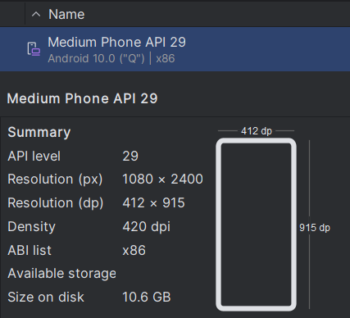

Evidence:

